Fahad Café Website Application report.

Fahad Alharbi

2018

Table of Contents

Introduction: 2

What is the goal of my project 2

Audience 2

Technologies that are used 2

External sources 2

Limitations and restrictions: 3

Features planning to do but I changed my mind 3

Initial Design 3

Principles for designing the website 3

sketching my design 4

Design the website: 8

Head section: 8

Body section 8

Header**:** 8

Footer: 10

Main content 11

Feedback and Reviews from DEV week 27

Conclusion 27

# Introduction:

## What is the goal of my project

* + Future business
  + to provide communities with the ability to access the Internet, enjoy a cup of coffee, and share experiences in a comfortable atmosphere
  + to let customers feel appreciated, supported and satisfied, every time they come in.

## Audience

* + This website is targeting (All ages) & target two different languages (Arabic and English)

## Technologies that are used

* + HTML 5, CSS 3, XML& XSL, JavaScript API, Animation CSS, jQuery

## External sources

* + Websites that I’ve used <http://www.responsivegridsystem.com/> <https://fonts.google.com/> - <https://www.foodiesfeed.com/> <https://www.pexels.com/> - <http://thestocks.im/> - all of them are free to use.
  + For social media icons and other icons: <https://ionicons.com/>
* <https://www.w3schools.com/>
* <https://simplesharebuttons.com/> for sharing link feature in menu.
* For animation, I have used this website <https://daneden.github.io/animate.css/>
* jQuery has been used to make the navigation sticky and navigation scroll <https://css-tricks.com/snippets/jquery/smooth-scrolling/>
* Google Map API <https://developers.google.com/maps/documentation/javascript/examples/marker-simple>

## Limitations and restrictions:

1. In this project, I have faced some difficulty in finding the appropriate text editor that help me to see the outcome in real time till I find (Brackets)
2. Understanding the XML and XSL and applying them in the Menu section of my website.
3. Apply some CSS properties like the CSS box model.
4. Apply Google maps API for the first time to my website.
5. Validate the contact form and connect it to the server using PHP.

### Features planning to do but I changed my mind

* I planned to incorporate a reserve table system in my website, so customers can book the time and date from that.
* I also thought to work on the server side of the website but as we have limited time during the term, I focused on the client side.
* Targeting any devices.
* Adding the website logo and different images to the different types of menu to make it so cool.

# Initial Design

## Principles for designing the website

* Images are getting more and more important in the website, so choosing great images and putting text on them is an essential part of my work.
* Choosing the appropriate color (Orange draws attention without being as overpowering as red. It means cheerfulness and creativity. Orange can be associated with friendliness, confidence, and courage.)
* Icons are also a good way of setting a friendly tone for my website
* The adequate use of whitespace makes a website look professionally designed.
* Build a layout by defining the visual hierarchy of my content. Whitespace is also important for this.
* My website should be designed in a way that ensures that both the user and the owner of the website achieve their goals. This is the user experience.
* studying well-designed websites from another designer.

## sketching my design

I was inspired by responsive website that targets every devices tablet, iPhone, laptops and so on and so forth. I have started by sketching my design on paper so that will help me out later when I build my final application.

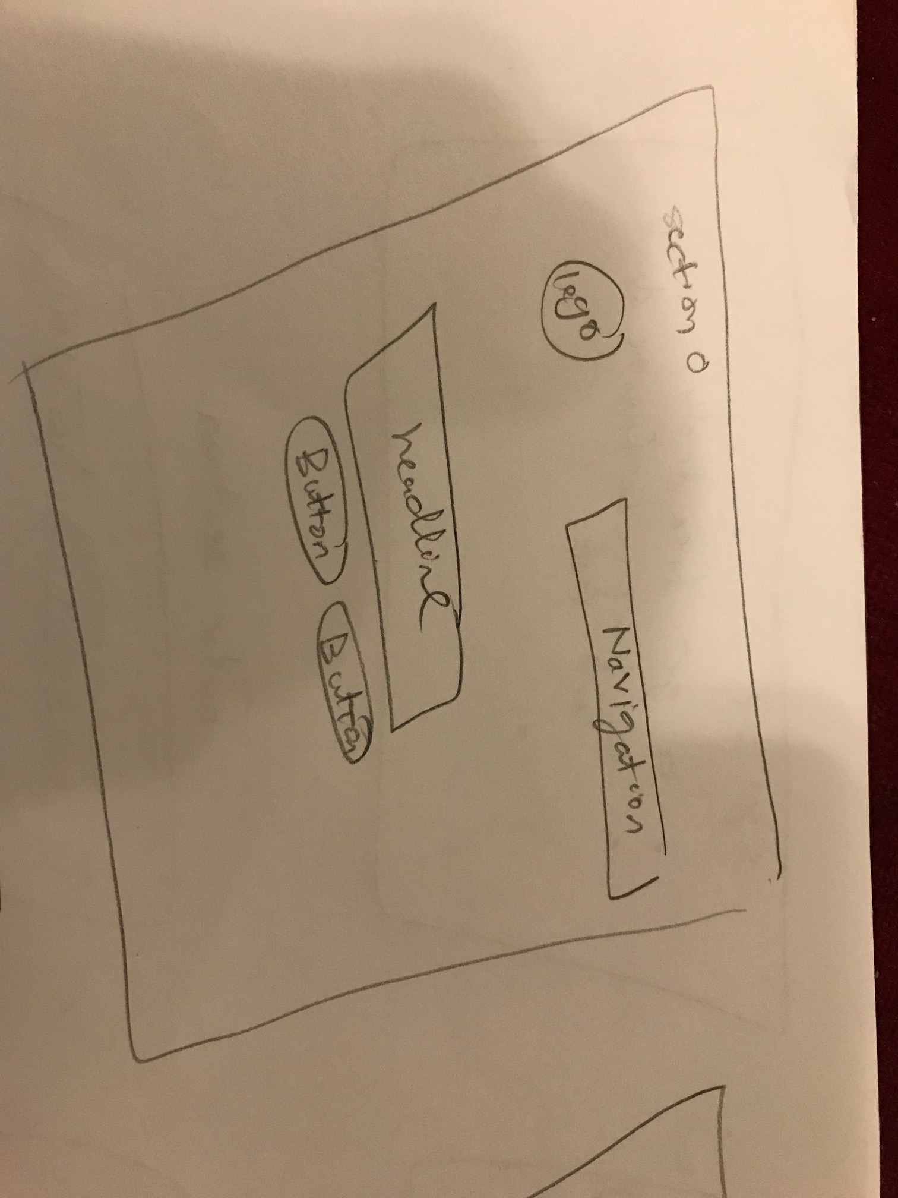

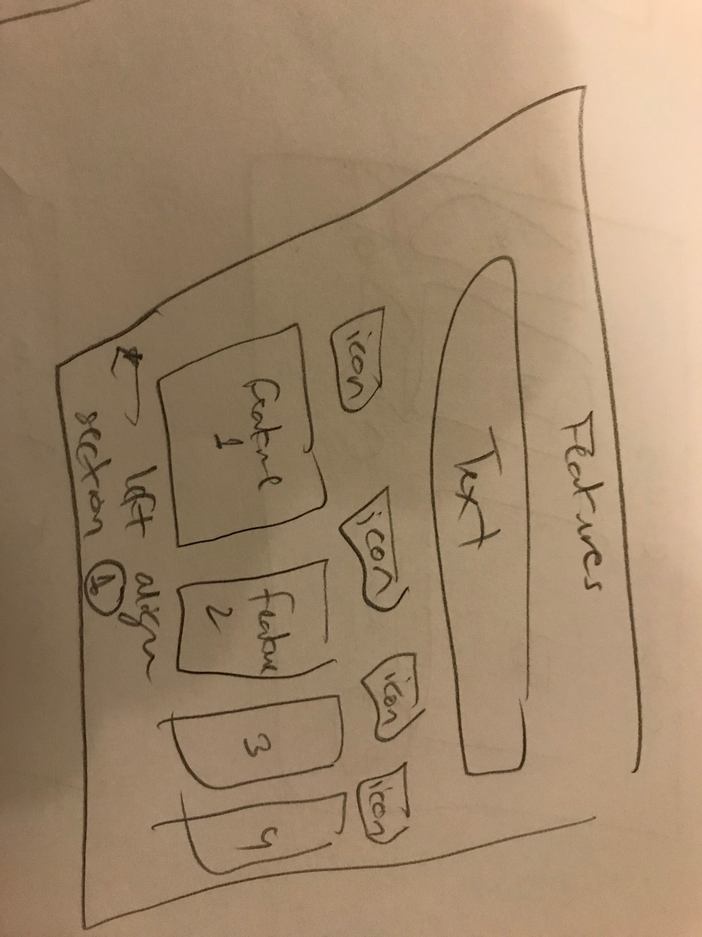

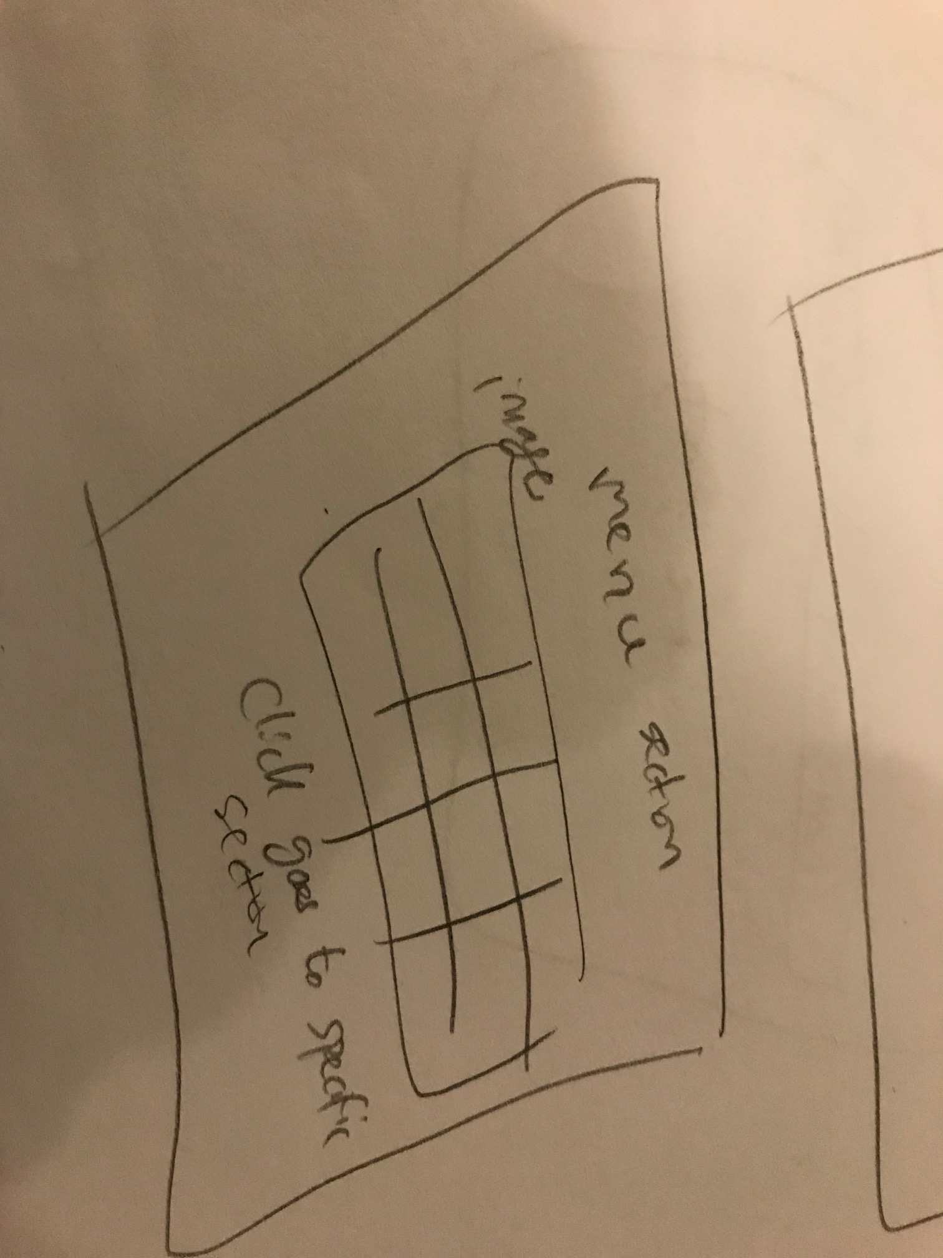

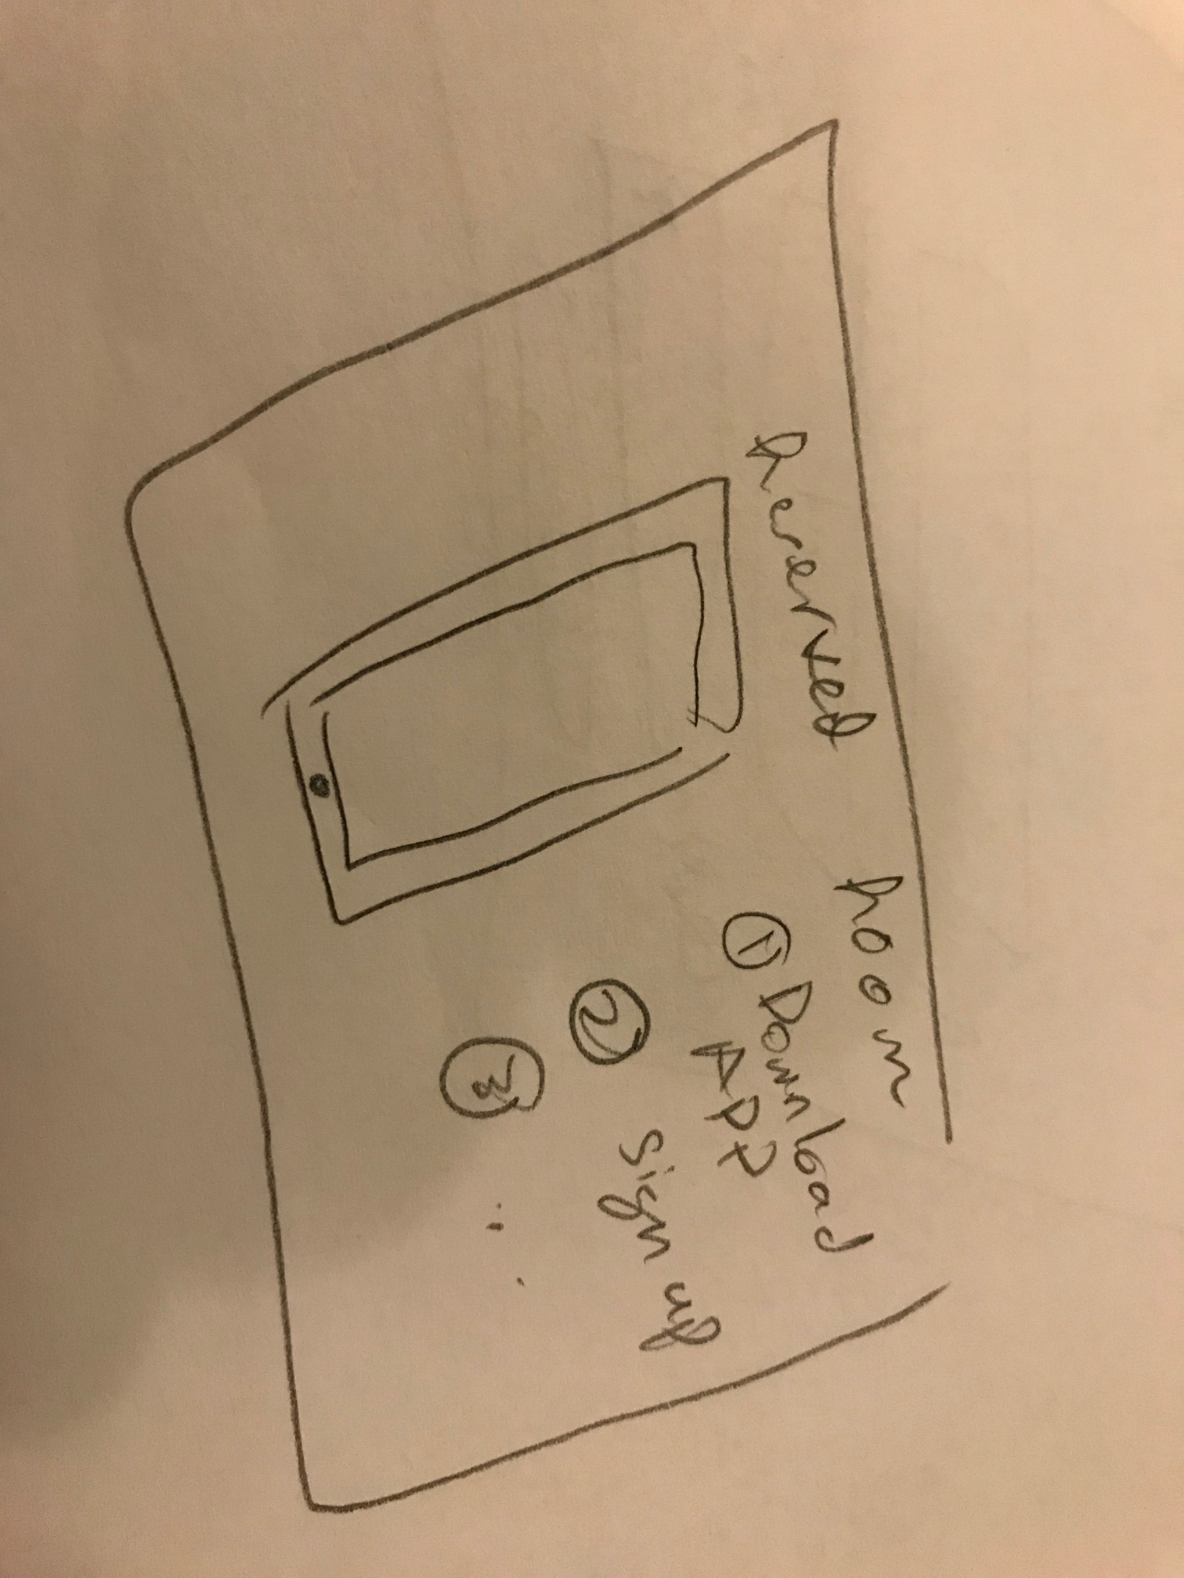

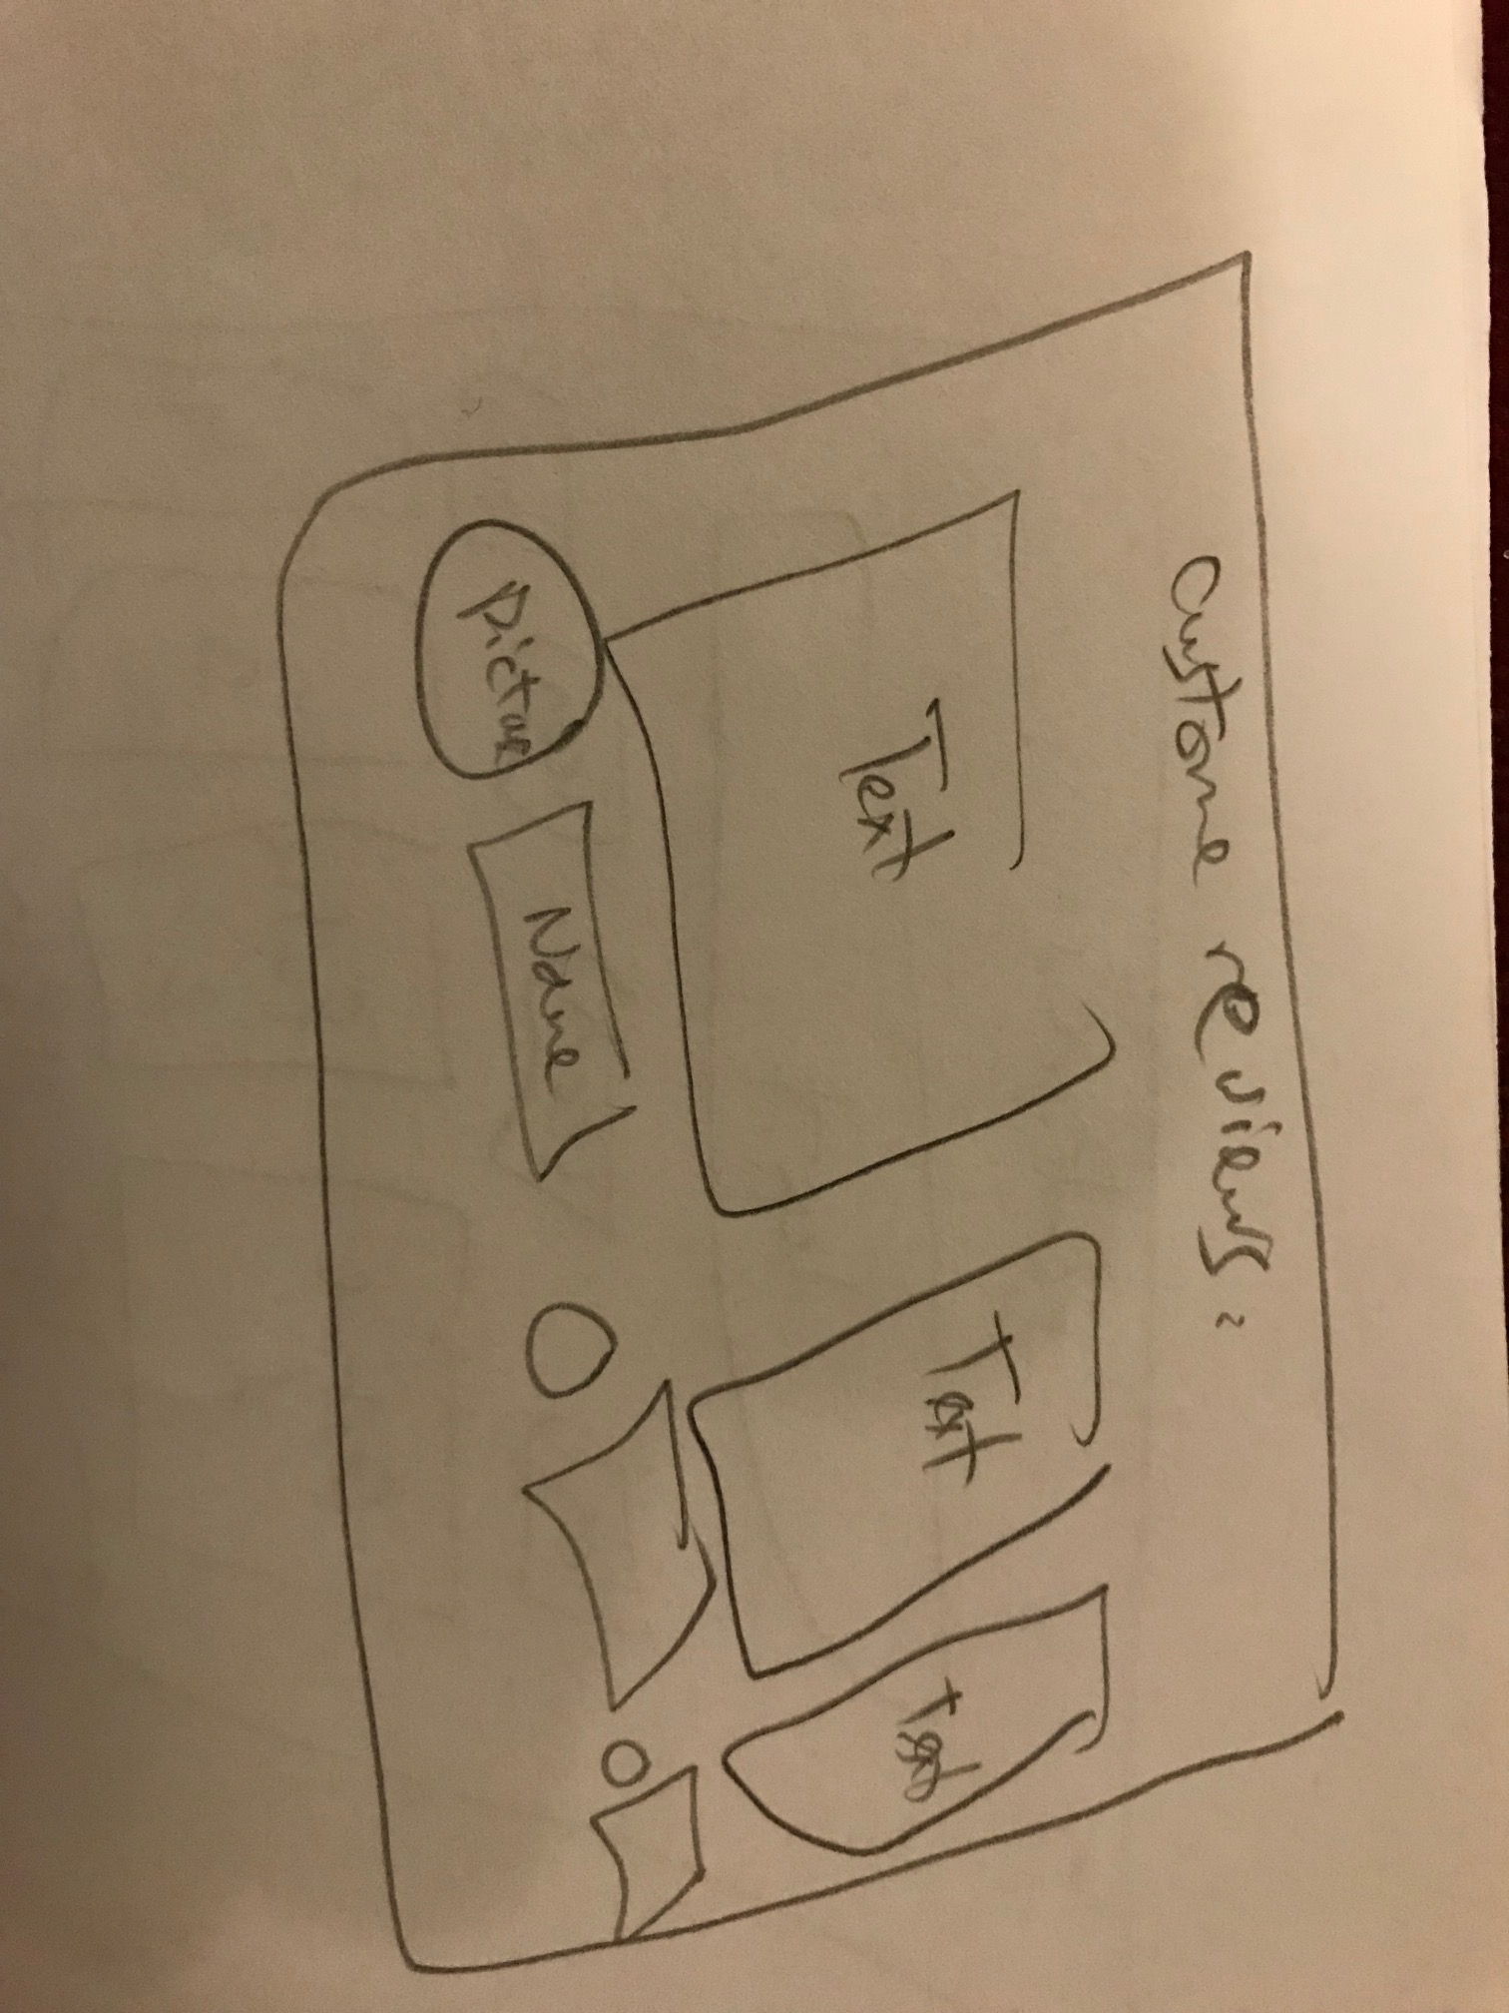

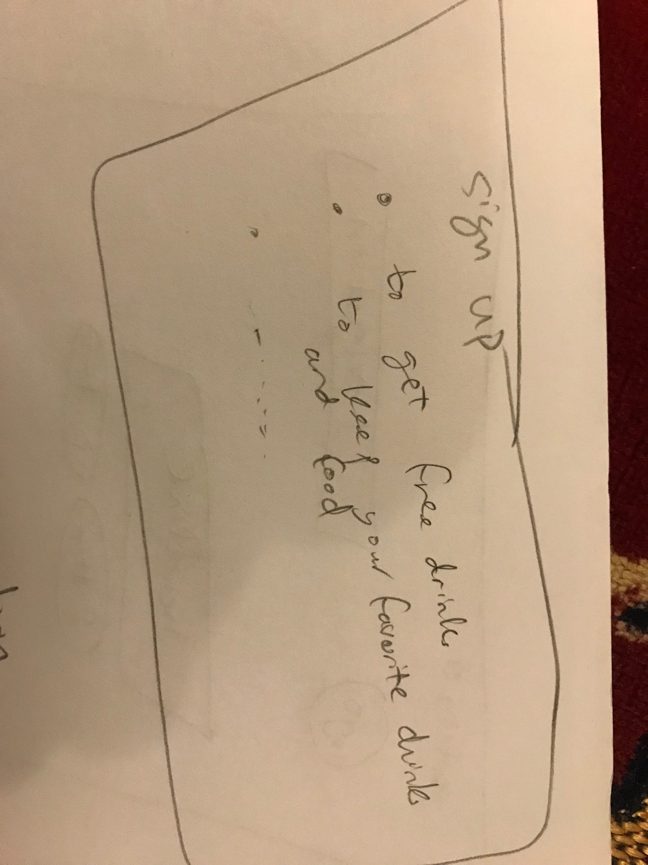

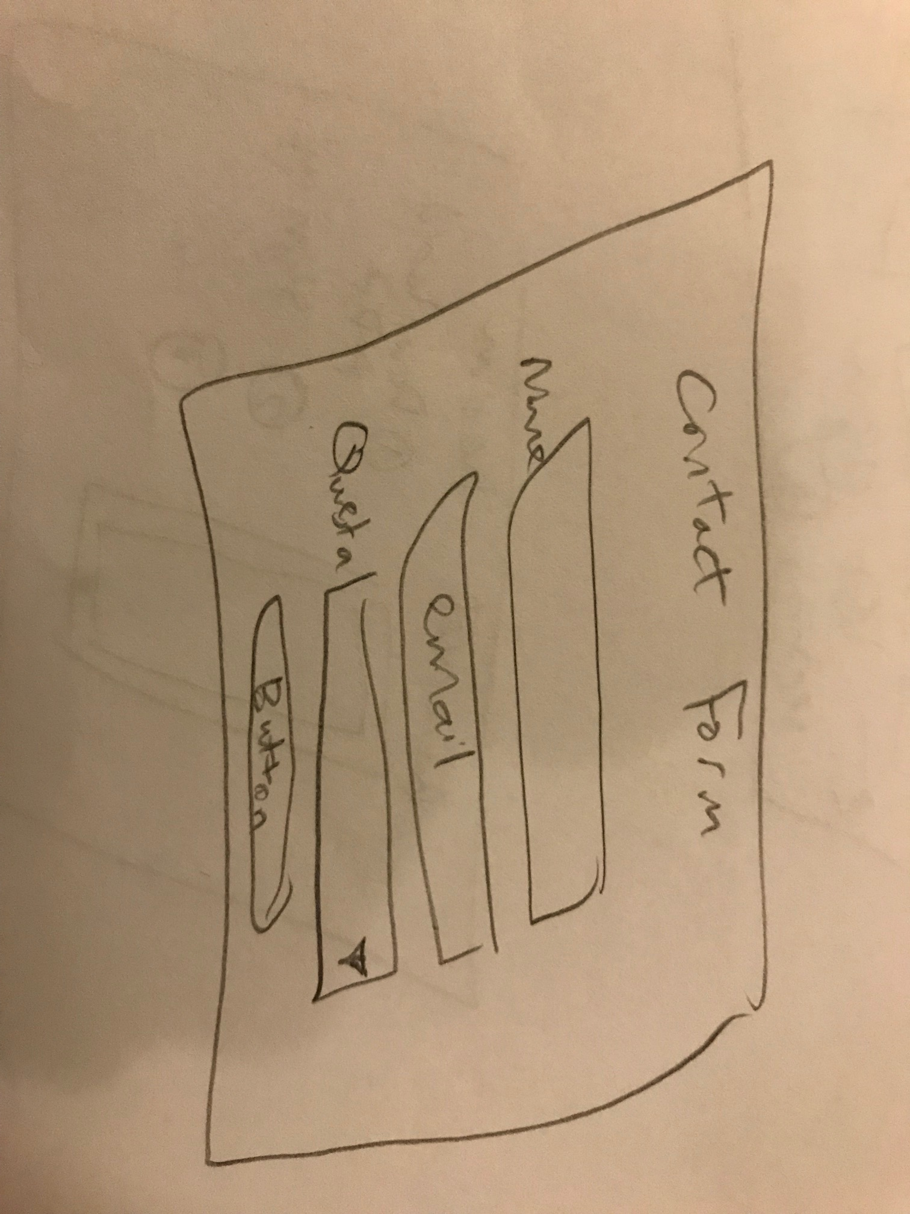

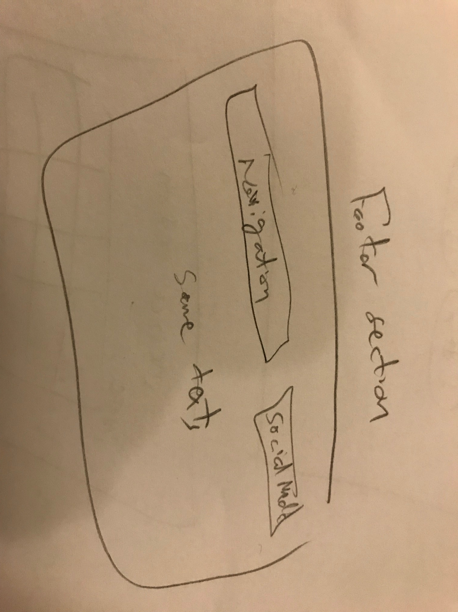

# Design the website:

## Head section:

The <head> element is a container for metadata and used to link to external style sheets. It contains <meta name="description"> <meta name="keywords"> and different files for jQuery and CSS files.

## Body section

### Header**:**

In the header section, the page is divided into 3 sections. Navigation part, headline and buttons, and Arabic and English language section. I have used <div></div> for different sections and <img> tag for the logo. I have used unorder list for different languages and navigation lists and then in the style, I have used list-style to be none to specify the type of list-item marker in a list. For the buttons, I have used: hover selector to style links when the mouse over them, and the: active selector to style links when I click on them. I have also used: link selector and border-radius to make the border look like a circle. To make the image darker, I have used the property linear-gradient and background-size: cover and background-position: center for positioning the image. There are also other properties in the CSS file, but I think what’ve mentioned is the most important to be mentioned.

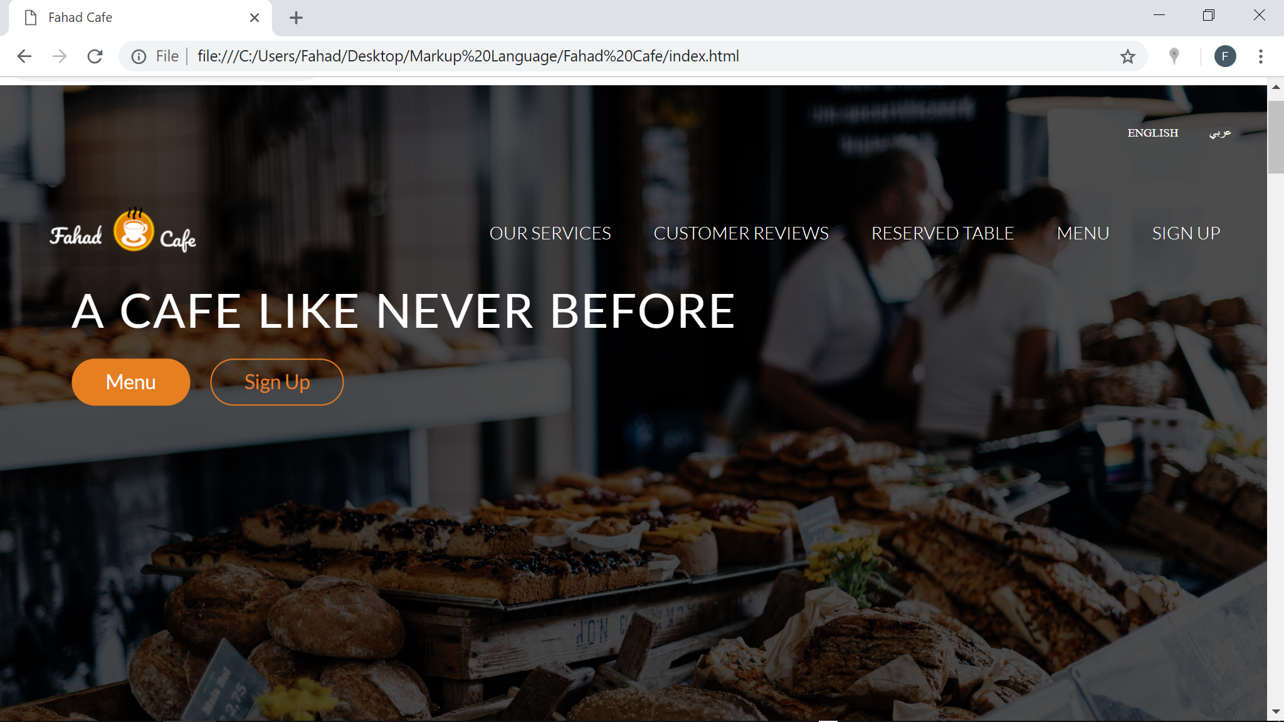

#### HTML Code:



### Footer:

In the footer section, I have used grid style to divide that part into two columns. The first column includes different sections about us, locations etc. The other section contains the social media icons. To make the element to be beside each other, float property has been used to specify how an element should float. Also, display property is used to be inline-block.

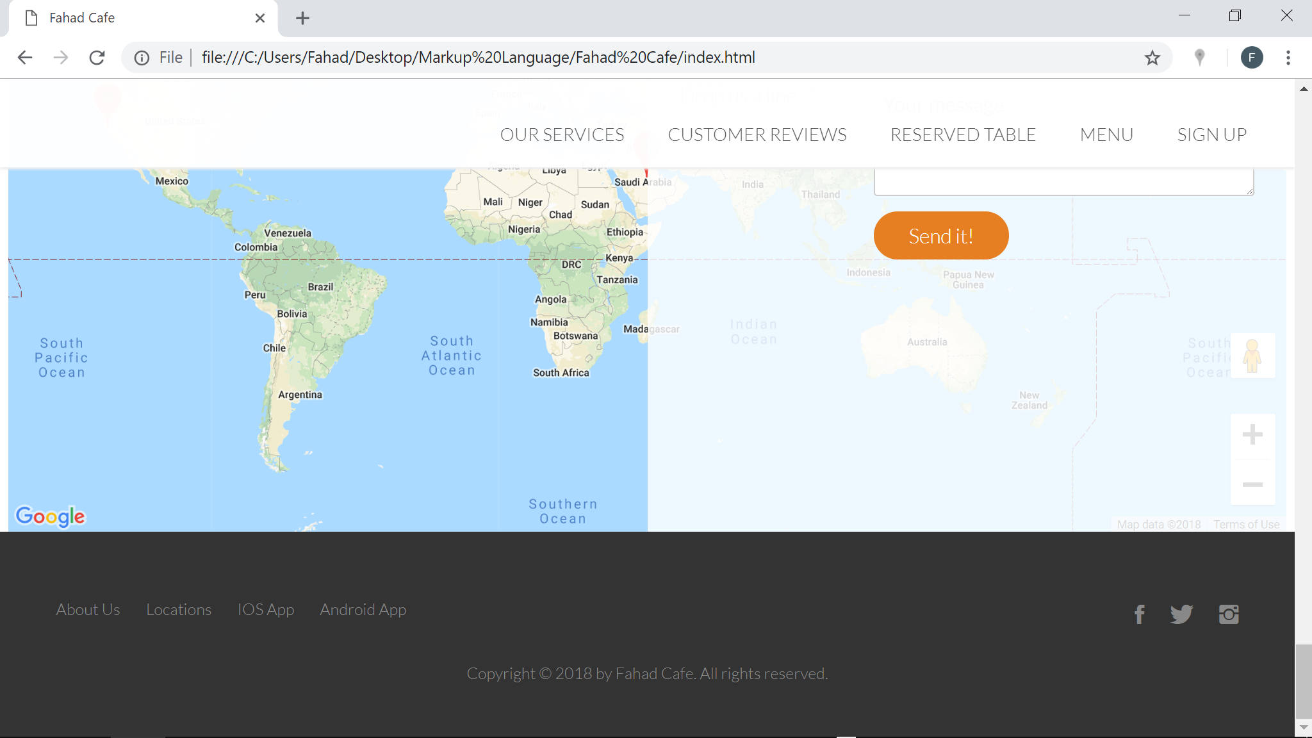

#### HTML Code:



### Main content

This section is divided into different parts. First of All, I have started with **features section** of the website. I divided that section into 4 columns using grid style (col span-1-of-4) and then using icon for each section and make icons bigger than its original shape. Then, I’ve created simple **sign up page** which contains some rewards for signing up in the website. The idea of this section is how to make a circle border around the number by using border-radius. After that, I’ve created the **menu page** with eight different pictures for each menu. I have integrated XML and XSL for this part for the sake of learning more about XML and XSL. in this part, I have used transform to zoom in and zoom out when I hover over the pictures which is an amazing effect to be added. I have also used overflow property to be hidden which makes the overflow clipped, and the rest of the content will be invisible. When I have used the XML with Menu section, I have used sharing links feature to give the customers the ability to share the menu with their friend and family and print out that. Moving to the **reserve table page**, I have divided this section into two columns. In the first column, I have incorporated a picture for iPhone, so I can use animation effect then to fade it up. The second column is just like the one in the sign-up page which contains numbers and some instructions for customer on how to reserve table on the website. Then, I have designed the **customer review page**, which contains reviews from Yelp for three different customers. Last section of the main content, it is the **contact form page** and **Fahad café locations**. The idea here is how to make one section over another by using different CSS property like z-index and absolute positioning. The form also works fine on server by printing a green message when all the form filled with appropriate data. Otherwise it will print a red error message.

#### Features Section

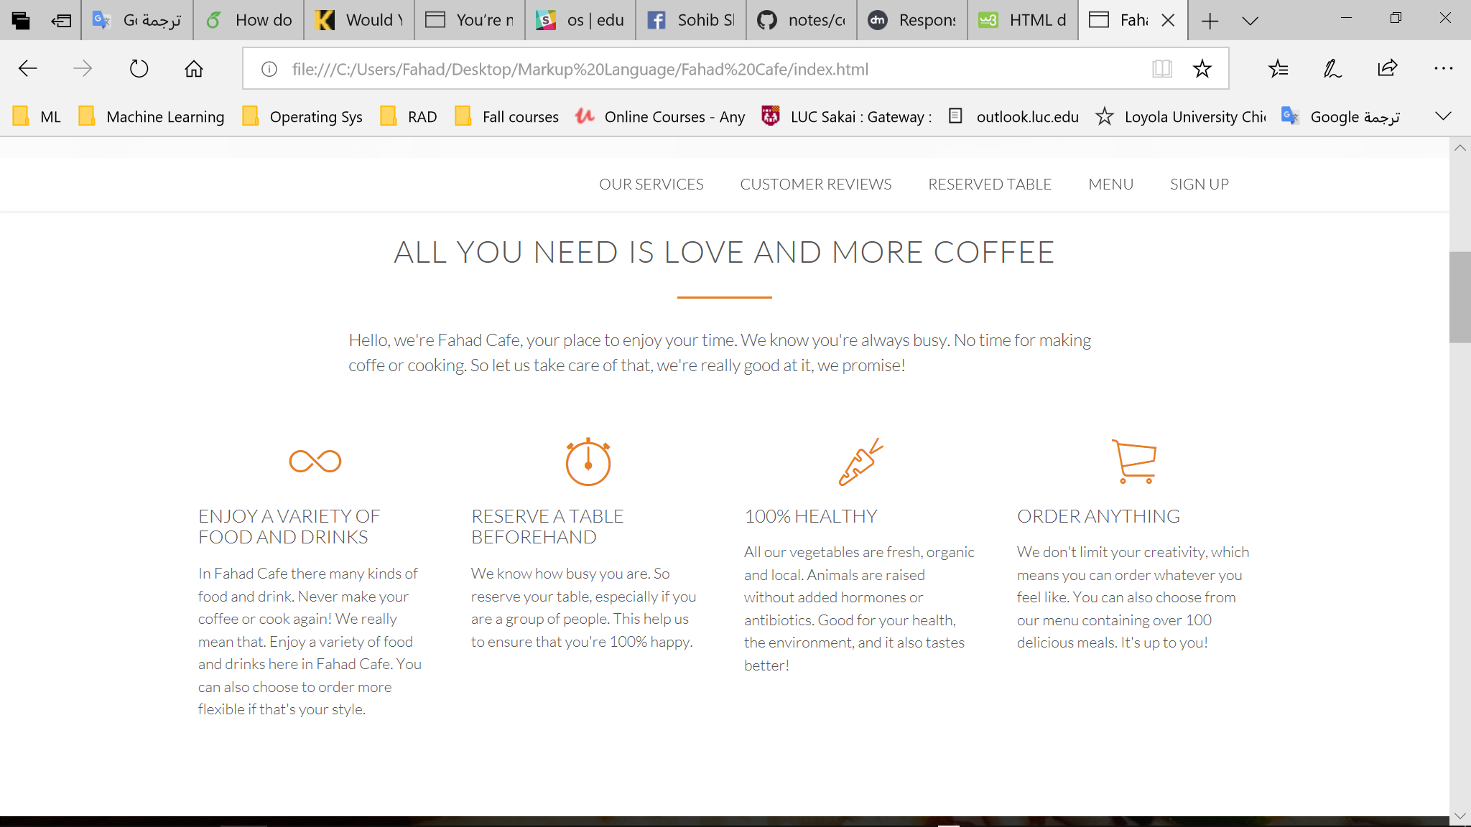

##### HTML Code:



#### Sign up Page

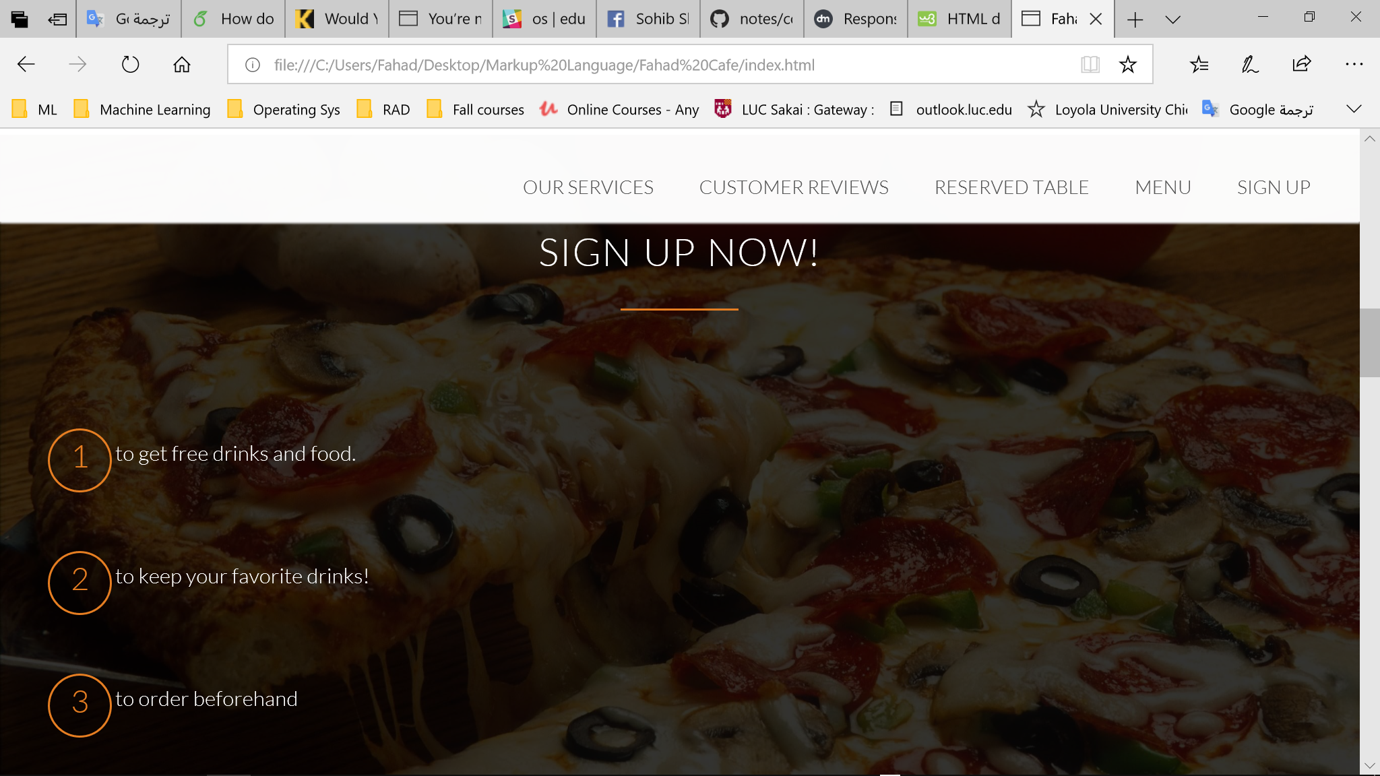

##### HTML code:



#### Menu Page

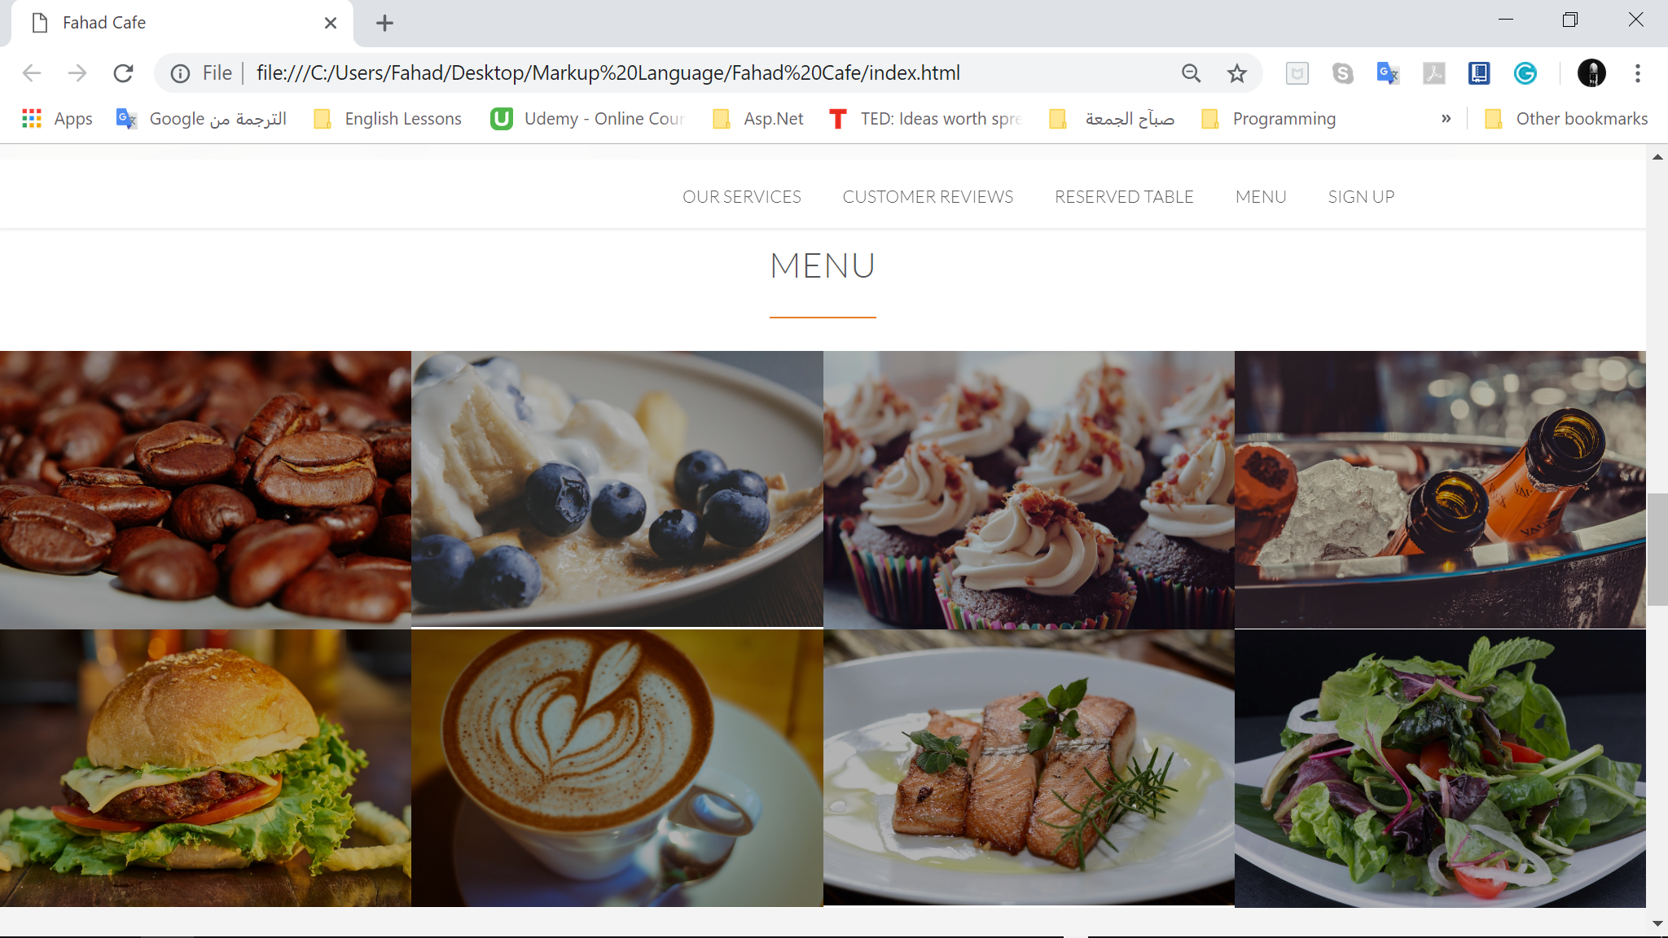

##### HTML code



##### XML code for Beans Menu



##### XSL code for beans Menu



#### Reserve Table Page

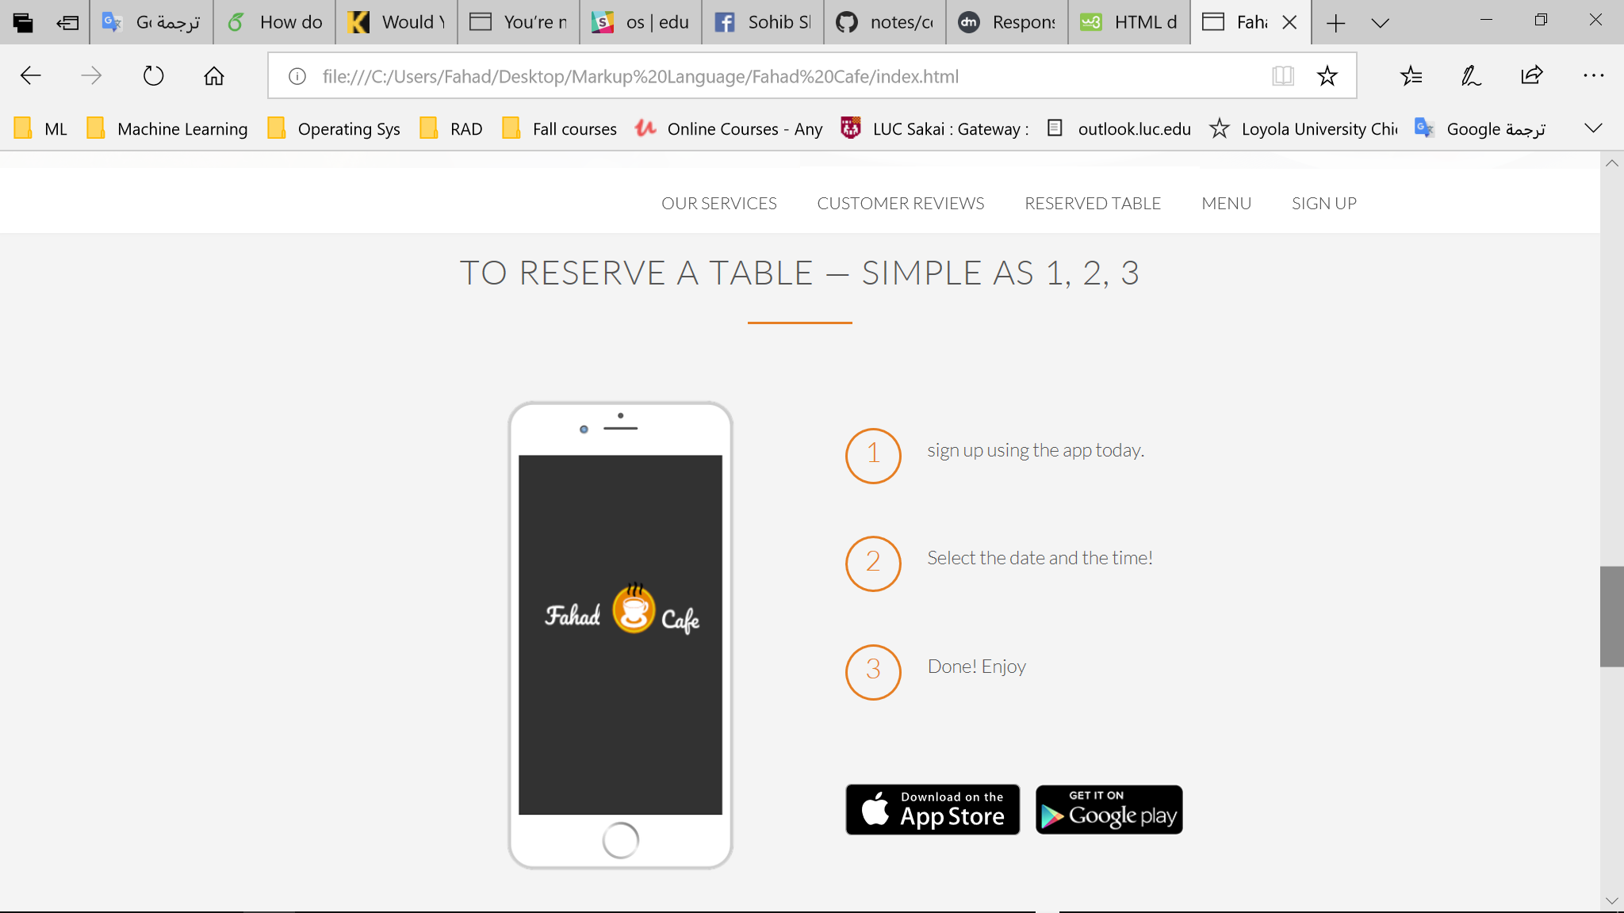

##### HTML code



#### customer review page

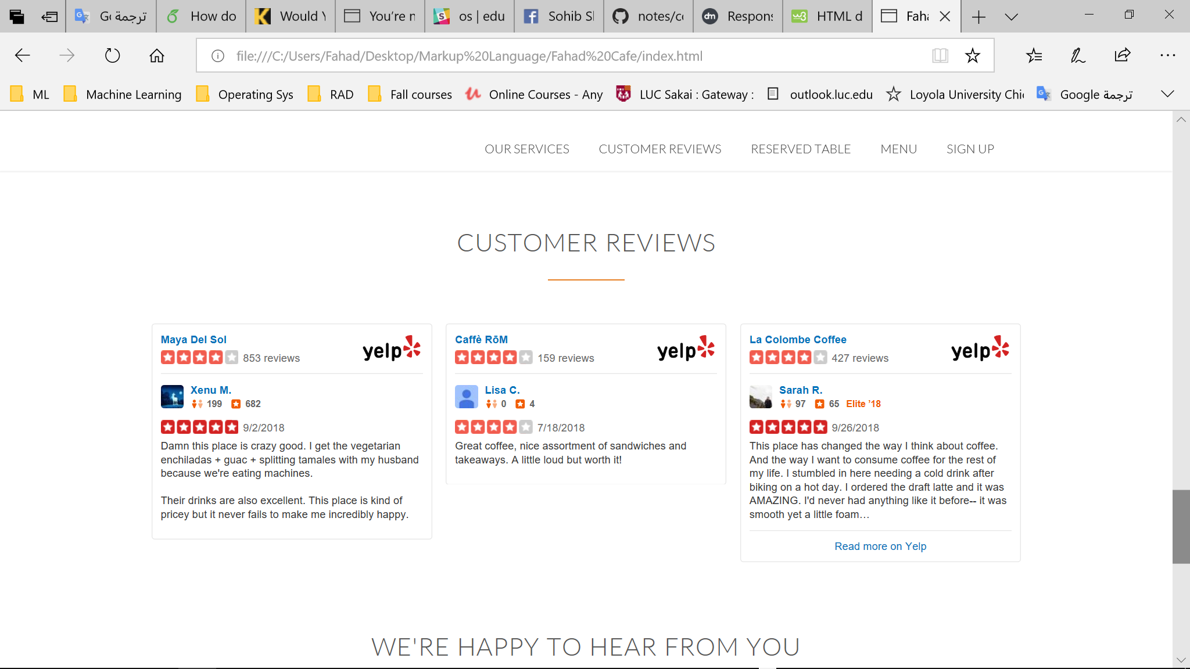

##### HTML code



#### contact form page

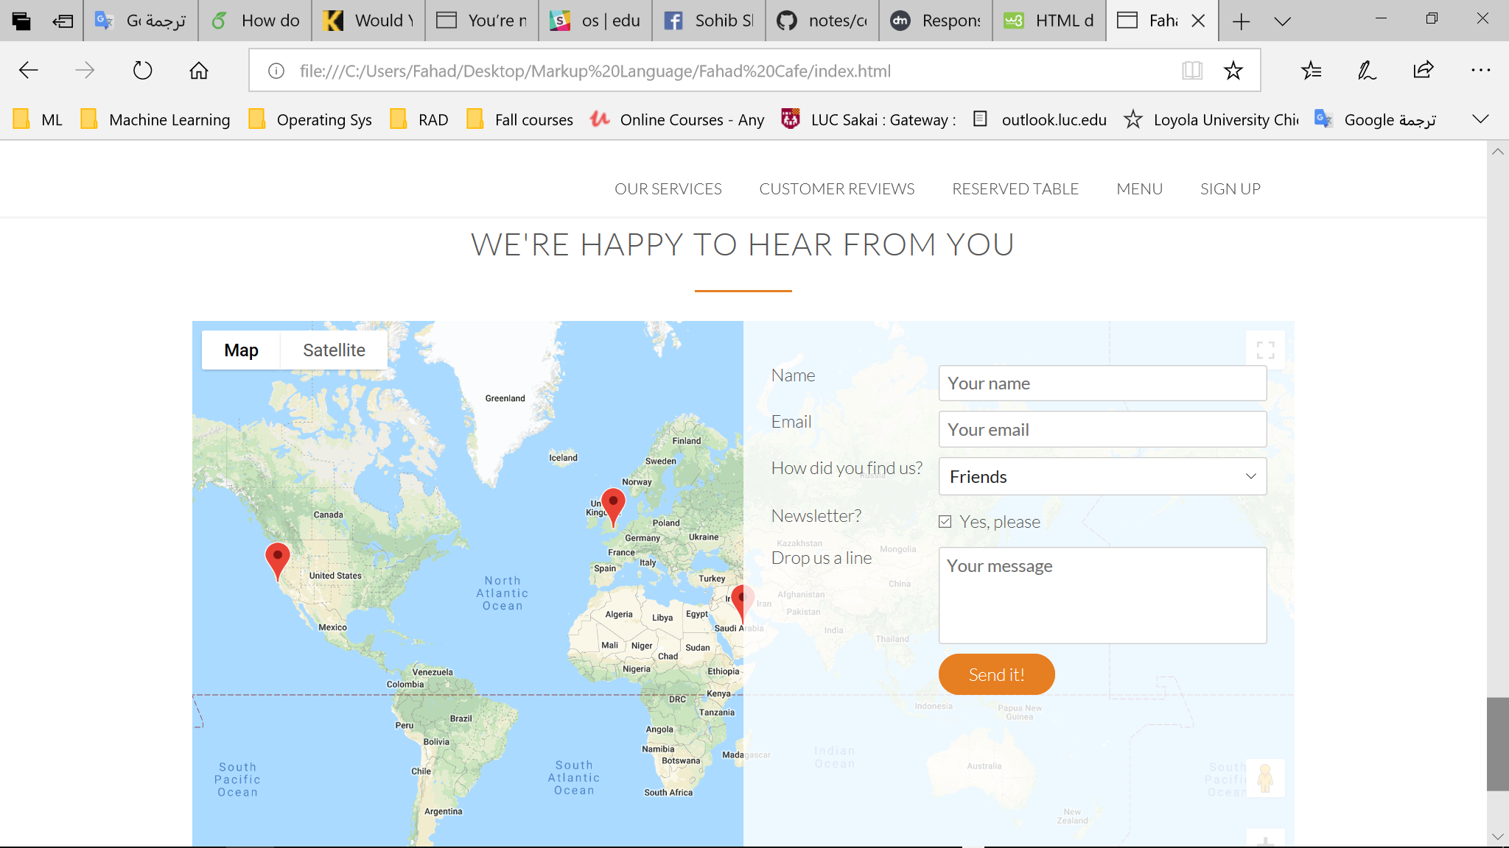

##### HTML code



##### JavaScript Code



## Feedback and Reviews from DEV week

I have changed several things in my design based on the reviews and feedback I got:

* in the review section, I was about to build the review from scratch by writing some reviews about Fahad Café and some pictures for different people. Then, I have been told to use Yelp API and I applied that to my website application.
* I have used sharing links feature in the menu which I have not planned to do in my website application
* I changed in header section like logo of the website and audio feature.
* Using Image in the Beans Menu by extracting that from XML tags.

# Conclusion

In this project, I have learned a lot about HTML5, CSS3 and some of its amazing properties, JavaScript API, jQuery plugins and XML. I’m so proud of what I’ve done so far. I wasn’t expecting I’ll do all of that, but with a feature like seeing my outcome in real time in Brackets text editor save me a lot of time. I’m also not satisfied with speed of my website and this is because it includes a lot of images, so I might optimize that in the near future and make it better.